A company wants to add a module to its portal that allows the employees to check information about their .

Database: **TaskManager**

|  |  |  |  |  |  |  |
| --- | --- | --- | --- | --- | --- | --- |
| Table: **Employee** | | |  | Table: **TaskSheet** | | |
| **Column** | **Data Type** | **Properties** |  | **Column** | **Data Type** | **Properties** |
| EmpID | Varchar (10) | Primary Key |  | TaskID | Auto Number | Primary Key |
| EmpName | Varchar (20) | Not null |  | EmpID | Varchar (10) | Not null |
| EmpPass | Varchar (20) | Not null |  | TaskName | Varchar (50) | Not null |
|  | | | | StartTime | DateTime | Not null |
| FinishTime | DateTime |  |

* Create a Login page which contains a single method called **LoginCheck()**. The method will take an **Employee ID** and **password** as parameters and will return **true** if the ID and password is found in the table, otherwise **false**. Shown in **Figure 1**.

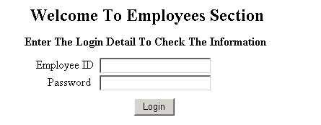

**Figure 1**

* If the ID and password is wrong then error message should be displayed on same page. If login success, the **TaskSheet** of the appropriate employee should be displayed as shown in **Figure 2**. The TaskSheet should have **a Welcome message** **with Employee name displayed**.

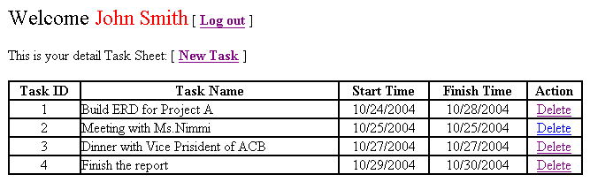

**Figure 2**

* When click on “**Log out**” hyperlink, it should bring back to the Login page.
* When click on “**Delete**” hyperlink, the appropriate Task should be **permanent deleted**
* When click on “**New Task**” hyperlink, the **Add New Task** page should be displayed as show in **Figure 3**

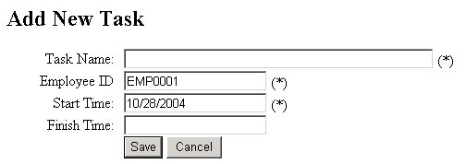

**Figure 3**

* All the mandatory fields are required (*)
* Employee ID textfield should not be editable and must be auto filled with the current login Employee ID
* Start Time textfield should have default value set to current date. Finish Time must be greater or equal to Start Time. When click on Save buton, the data should be saved to **TaskSheet** table

🞐 🞐 🞐